District 20 Needs GSR volunteers!
Are you passionate about service in AA? Consider becoming a General Service Representative (GSR) — the vital link between your group and your AA District.
Did you know your group is part of District 20, one of the 27 districts in Area 30? As a GSR, you’ll help carry the group’s voice to the district and beyond, while staying informed about AA’s broader service structure.
It’s a rewarding opportunity to get involved in district activities like:
- Outreach events: BBQs, dances, beach gatherings
- Service events: pre-assemblies, conferences, conventions, workshops, alcathons
- Special committees: Archives, Public Information, Grapevine, Treatment Facilities, and more
Whether you're new to service or looking to deepen your involvement, District 20 welcomes you! Come learn more and be part of something bigger.
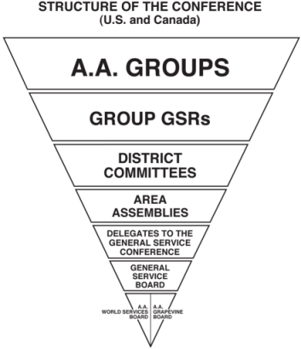

District Meetings are held:

 | 1st Monday of the Month (2nd Monday if holiday)
 | 7:00 PM EST
 | ZOOM ID: 898 7335 5689
 | Password: District20
 | North Andover Sr Center
 | 481 Sutton St, North Andover, MA 01845
 | aadistrict20ma.org

