District 20 Area 30
Member Handbook
Eastern Massachusetts | Merrimack Valley

A plain-language guide to service, roles, and how we work together.

What Is District 20?
District 20 is a service body. That means we exist to support AA groups -- not to run them, govern them, or tell them what to do.
We serve the Merrimack Valley area of Eastern Massachusetts, including communities like Haverhill, Lawrence, Newburyport, Andover, Methuen, and more. We are part of Area 30, which connects us to AA as a whole.

Key idea | We are trusted servants. The groups we serve always come first.

District 20 exists to:
- Help local AA groups stay connected to each other and to Area 30
- Share information from the General Service Conference
- Encourage members to get involved in service beyond the meeting room
- Support special committees like Public Information, Corrections, and Accessibilities

We meet on the first Monday of every month at 7:00 PM. You can join in person at the North Andover Senior Center (481 Sutton Street) or on Zoom (Meeting ID: 898 7335 5689 / Passcode: District20). If the first Monday falls on a holiday, we meet the second Monday instead.

What Is a District, Anyway?
Think of it like this: each AA group stands on its own. Groups are autonomous -- they run their own meetings, elect their own officers, handle their own money. Nobody tells a group what to do.
But groups don't have to stand alone. A District is simply a collection of AA groups who agree to work together on shared service work. The District doesn't have any power over groups. It just helps connect them.

Think of it this way | A group is a single voice. The District is where those voices come together to speak about things that affect all of us.

At The District Level

At the District level, members serve as a vital link in A.A.’s communication and service structure. GSRs and trusted servants:
• Bring the group conscience and shared experience of their home groups to the District
• Carry District discussions, resources, and updates back to their home groups
• Coordinate service efforts that extend beyond any single meeting
• Support cooperation between groups within the District
• Connect local A.A. efforts to the broader community through service committees such as Archives, PI/CPC, Grapevine/La Viña, Accessibility, Corrections, and Treatment
The District is where local service work is shared, strengthened, and organized. It is the place where groups come together — not to govern one another — but to support one another in carrying the message.

How the District Connection to Area 30?

The District then connects down to Area 30.
We intentionally use the word “down” because A.A.’s service structure is often illustrated as an upside-down triangle. In this model, the Groups are at the top — reflecting that they are the foundation and ultimate authority in A.A.
From there, communication and group conscience flow downward through the District to the Area Assembly, then to the Delegate, and ultimately to the General Service Conference. The Conference works with the General Service Board and the General Service Office (GSO) in New York, where A.A. coordinates literature, public information, and services that support the Fellowship as a whole.
This structure ensures that authority begins with the groups and that service bodies exist not to rule, but to serve.
.
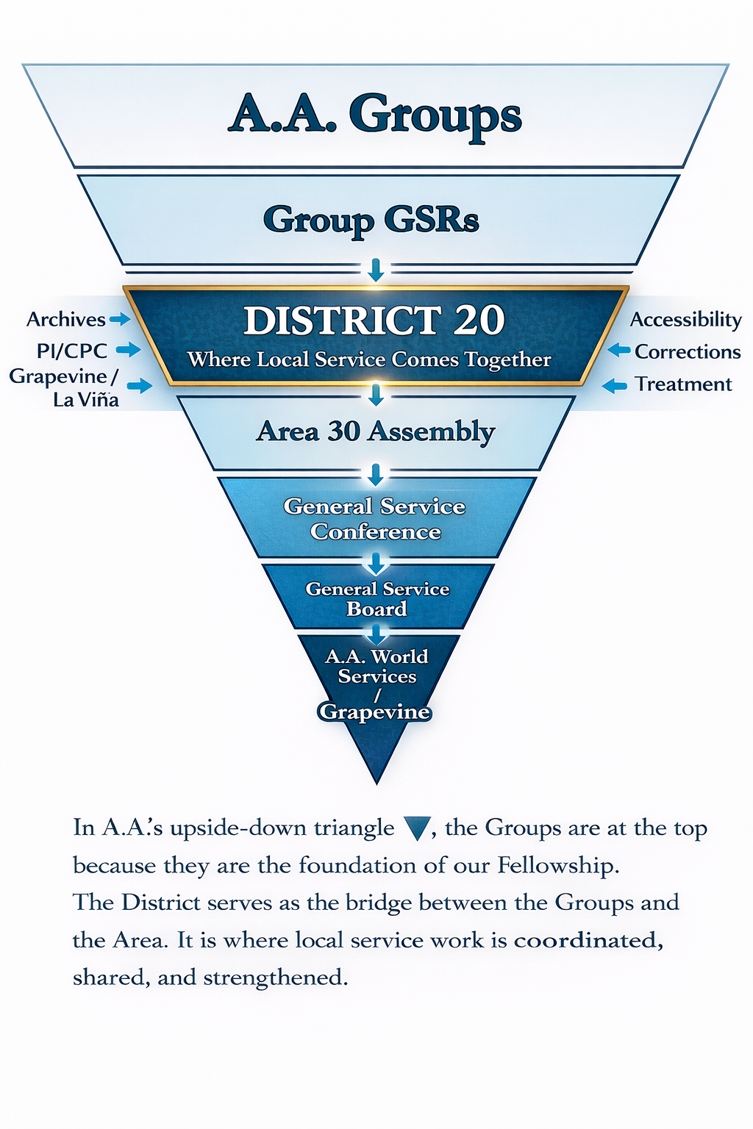

Rotation and Service: Why We Do It This Way
One of the most important ideas in AA service is rotation. It means that leadership positions are temporary on purpose. People serve for a set term, then step aside so someone else can step up.

Why Does Rotation Matter?
It might seem like it would make more sense to keep an experienced person in a role as long as possible. But AA's experience has shown something different:
- Rotation keeps power from getting concentrated in one person or group of people
- It gives more members a chance to serve and grow
- It keeps fresh ideas and energy moving through the Fellowship
- It protects the group from depending too much on any single person

In short | Rotation is how we make sure AA belongs to everyone -- not just to whoever has been doing the job the longest.

This doesn't mean experience doesn't matter. It does. An outgoing DCM or GSR can be incredibly helpful to whoever comes next. Passing on what you've learned is part of the service.

Service Works Differently for Different People
Not everyone comes to service the same way. Some people walk through the doors of AA and immediately want to get involved. Others take longer to feel ready. Both are completely normal.
Some people start with small service at the group level: making coffee, setting up chairs, being a greeter. That's real service. It matters. And for many people, it's the bridge that leads to bigger involvement down the road.
Others find themselves drawn to District or Area work earlier. That's okay too. The important thing is that the door is always open.

Roles and Positions in District 20
Here's a plain-language look at each service position -- what it involves, how long the term is, and why it matters.

GSR -- Group Service Representative
Term: 2 years (aligned with the General Service Conference cycle) Suggested sobriety: Varies by group; 1 year suggested minimum
What you do:
- Represent your home group at District meetings
- Bring news and information from the District back to your group
- Voice your group's conscience on matters brought to the District
- Vote on District business on behalf of your group
- Help your group stay connected to AA as a whole
Why it matters:
The GSR is the most important link in the whole service structure. Without GSRs, groups have no voice at the District level, and District information never reaches the groups. If you're a GSR, you're not just attending meetings -- you're carrying the pulse of your group.

Can a GSR also hold a District role? | Yes! A GSR can take on a committee chair or other District position at the same time. The two roles are separate. Just be transparent with your home group about what you're committing to.

DCM -- District Committee Member
Term: 2 years Suggested sobriety: Suggested 2+ years; some experience at group or District level is helpful
What you do:
- Chair the monthly District meeting
- Serve as the District's representative to Area 30
- Share information between the District and the Area Committee
- Support GSRs and committee chairs in their work
- Attend Area Assemblies and other Area events
- Help coordinate District activities and service events
Why it matters:
The DCM is the main connection between District 20 and Area 30. It's a big job, but it doesn't require being an expert -- it requires showing up consistently, listening well, and caring about the Fellowship.

Alternate DCM
Term: 2 years Suggested sobriety: Suggested 1-2 years
What you do:
- Step in for the DCM when they are unavailable
- Support the DCM throughout the term
- Attend District meetings and Area events
- Learn the role in preparation for potentially serving as DCM in the future
Why it matters:
The Alt DCM role is a great way to get a real feel for District-level service before stepping into the DCM chair. Think of it as a training ground -- and a vital backup.

Secretary
Term: 1-2 years (varies) Suggested sobriety: Suggested 1 year
What you do:
- Take minutes at District meetings and distribute them to members
- Handle District correspondence and communications
- Keep records of attendance and actions taken at meetings
- Help maintain the District's files and history
Why it matters:
Good records help the District function. Minutes aren't just paperwork -- they're how we remember what we decided, what we committed to, and who was there. A reliable Secretary keeps everything running smoothly behind the scenes.

Treasurer
Term: 1-2 years (varies) Suggested sobriety: Suggested 1-2 years; some comfort with basic bookkeeping is helpful
What you do:
- Track District income and expenses
- Present a financial report at each District meeting
- Pay approved District expenses
- Help prepare and present an annual budget
- Ensure the District follows AA's financial guidelines
Why it matters:
AA runs on Tradition Seven -- we are fully self-supporting. The Treasurer helps make sure District 20 handles its money in a way that's transparent, honest, and consistent with AA's principles. No accounting background required -- just willingness and care.

Committee Chairs
District 20 has a number of standing committees, each focused on a specific area of service. A Committee Chair leads that work -- coordinates volunteers, reports to the District, and helps carry AA's message in a specific direction.

Committee | What They Do
Public Information (PI) | Helps the public understand what AA is and what it isn't. Works with media, schools, and community organizations.
Cooperation with the Professional Community (CPC) | Builds relationships with doctors, counselors, social workers, and others who might refer people to AA.
Corrections | Carries the AA message into correctional facilities -- prisons and jails -- where many people can't come to us.
Treatment Facilities Liaison (TFL) | Connects with treatment centers and hospitals to help patients learn about AA while they're getting help.
Accessibilities | Makes sure AA meetings are available to people with physical limitations, and helps connect people leaving institutions to meetings nearby.
Archives | Preserves the history of AA in our District and Area -- old documents, photos, records, and stories.
Grapevine / La Vina | Promotes AA's international journal -- the 'meeting in print' -- and its Spanish-language counterpart La Vina.

You don't have to be an expert to chair a committee. You just need willingness to show up, reach out, and keep things moving. Most committees have other volunteers who help, and the DCM is always available for support.

How the Service Structure Works Together
It helps to see how all the levels connect. Here's the simple version:

Your Home Group | -> | The foundation. Everything starts here. Groups make decisions through their group conscience and elect a GSR.
GSR | -> | Carries the group's voice to the District and brings District information back.
District 20 | -> | Where GSRs and District officers meet monthly to share info, support service, and coordinate work.
DCM | -> | Carries the District's voice to Area 30 and brings Area information back to the District.
Area 30 | -> | Covers all of Massachusetts. Holds Assemblies and connects to the General Service Conference.
General Service Conference | -> | Meets annually in New York. Represents AA as a whole on matters of literature, policy, and service.

This structure isn't a chain of command -- it's a chain of communication. Information and accountability flow both ways. Groups inform the District, the District informs Area, and it all flows back down again.

Rotation Timeline and Suggested Succession
AA service runs on a two-year cycle. This section is meant to help District 20 members understand when elections happen, why the timing matters, and who might be in a good position to step into a new role when the time comes.

This is not a rigid rule -- it's a suggested guide based on how the cycles line up. Every situation is different, and common sense always applies.

Why the Timing Matters: Following the Area 30 Cycle
Area 30's Delegate and officers serve two-year terms. The current cycle ends December 31, 2026. A new Delegate and new Area officers begin January 1, 2027. Elections for those Area positions take place at the November 2026 Assembly.

District 20 positions ideally rotate around the same time -- so that when new Area leadership takes over, the District also has fresh representation ready to work alongside them. This creates a smoother handoff of knowledge, relationships, and momentum across the whole service structure.

The big picture | When Area leadership rotates, it helps for District leadership to rotate too. That way everyone is learning together, building new relationships together, and no one is carrying too much institutional knowledge alone.

The Rotation Calendar: A Suggested Timeline
Here is how the 2025-2027 cycle is expected to unfold for District 20 and Area 30:

Year | Month | What Happens
2025 | Ongoing | Current DCM, Alt DCM, Secretary, Treasurer, and Committee Chairs are serving their terms. GSRs are active in their groups.
2026 | Early | District members who are thinking about stepping into a new role should start conversations with their sponsor and current officers. No pressure -- just awareness.
2026 | Spring | Area 30 begins preparing for the November Assembly. GSRs and the DCM attend Area events and bring information back to the District.
2026 | Sept/Oct | District 20 should begin having internal conversations about which positions are coming up for rotation and who might be interested in stepping up.
2026 | November | Area 30 Assembly -- elections held for Area Delegate and Area officers for the 2027-2028 term. District 20 elections for DCM, Alt DCM, and other rotating positions are also typically held around this time.
2026 | Dec 31 | Current Area 30 Delegate and officers complete their term. Current District 20 officers in rotating positions complete their service.
2027 | Jan 1 | New Area 30 Delegate and officers begin. New District 20 officers begin. The new two-year cycle starts.
2027 | Ongoing | New leadership settles in. Outgoing officers are encouraged to be available to answer questions and pass on what they've learned.

Who Might Be Ready to Step Up?
There is no official list of who should move into which role -- that is always up to the group conscience and the individuals involved. But based on how service experience tends to develop, here are some suggested pathways:

Think of these as stepping stones, not requirements:

Active GSR | -> | Alt DCM | A GSR who has served at least one term has a solid foundation for District-level leadership.

Alt DCM | -> | DCM | The natural next step. Alt DCMs who have attended meetings, supported the DCM, and attended Area events are well prepared.

Committee Member | -> | Committee Chair | Someone who has volunteered on a committee for a term is often the best candidate to chair it next.

GSR / Group Officer | -> | Secretary or Treasurer | Members with group-level service experience often transition well into District administrative roles.

Outgoing DCM | -> | Area involvement | Former DCMs often go on to serve at the Area level -- on committees, as Delegate candidates, or in other Area roles.

Important note | These are suggestions, not rules. Someone serving in a role for less than a full term may not be ready to rotate out yet -- and that is completely fine. The goal is continuity and good service, not just change for the sake of change.

What If Someone Wants to Stay?
Rotation is a principle, not an absolute law. If someone is mid-term and doing strong work, it may not make sense to replace them just because an election cycle is happening. Here are some good questions to ask:

- Has this person served at least one full term in this role?
- Is there someone ready and willing to step in?
- Does the person currently in the role have a sense of whether they want to continue?
- What does the group conscience of the District say?

There is wisdom in knowing when to stay and wisdom in knowing when to step aside. Both take honesty and humility. Neither should be forced.

Keep in mind | Serving out a full term and then stepping down gracefully is itself a form of leadership. Helping the next person get oriented, passing on notes and contacts, and staying available for questions -- that's the rotation working the way it's supposed to.

Getting Involved: There's a Place for You
Whether you've been sober for one year or twenty, there is a place for you in service. And the more members who participate, the healthier our Fellowship becomes.

Not Sure Where to Start?
Here are some easy first steps:
- Talk to your group's GSR and ask how you can help
- Come to a District meeting -- just to observe. You don't need a position to show up
- Ask a committee chair if they need volunteers
- Let your GSR know you'd be willing to serve as the Alternate GSR for your group

Remember | You don't have to wait until you feel 'ready.' Most people who serve in AA say they learned the role by doing it. The willingness to try is what matters most.

A Note on Qualifications
AA doesn't require academic degrees, professional experience, or impressive resumes. The most important qualifications for any service role are:
- A desire to help
- Willingness to show up consistently
- An honest effort to represent the people you serve, not just your own opinion
- Enough sobriety and stability to handle the responsibility

If you're not sure whether you're ready for a particular role, talk to your sponsor, your DCM, or someone who has held that position before. They can help you figure it out.

A Living Document
This handbook is not a rulebook, and it's not meant to replace the AA Service Manual. It's meant to help members of District 20 understand how we practice service here -- today -- in plain language.
It will change over time, just like the Fellowship does. If something here is confusing, incomplete, or out of date, please say so. The best handbooks are the ones that keep getting better.

District 20 Monthly Meeting | 1st Monday of every month at 7:00 PM | North Andover Senior Center, 481 Sutton Street | Zoom ID: 898 7335 5689 | Passcode: District20

Revision History

- V1. March 2, 2026

